Company Name |  |  |  |  | UTILITYS SERVICES (NE) LIMITED. |  |  |  |  |  |  |  |  | Project title |  |  |  |  |  |  |  | Working in Underground Structures
Location |  |  |  |  | National |  |  |  |  |  |  |  |  | Contract no.
Method statement title |  |  |  |  | Working in BT Underground Structures |  |  |  |  |  |  |  |  | Reference |  |  |  |  |  |  |  | USL.HSMS.MS.014
Description of work
This method statement has been developed and must be read with the following risk assessment
Risk Assessment reference |  |  |  |  |  |  |  |  |  |  |  |  |  | Title
POWRA |  |  |  |  |  |  |  |  |  |  |  |  |  | POINT OF WORK RISK ASSESSMENT
Work commences on
Areas to be worked in
Duration of work (actual or estimated)
Number of workers (actual or estimated)
Personnel (include details of all personnel involved in the task and any specific training, skills or qualification required)
Name |  |  |  |  |  |  |  | Position |  |  |  |  |  |  |  |  |  |  |  | Competence details
Operative 1 |  |  |  |  |  |  |  | Gang Foreman |  |  |  |  |  |  |  |  |  |  |  | Fully trained BT Openreach Engineer & (IPAF / ALLMI)
Operative 2 |  |  |  |  |  |  |  | Second man |  |  |  |  |  |  |  |  |  |  |  | Fully trained BT Openreach Engineer & (IPAF / ALLMI)
Operative 3 (when applicable) |  |  |  |  |  |  |  | Third man |  |  |  |  |  |  |  |  |  |  |  | Fully trained BT Openreach Engineer
Emergency arrangement details
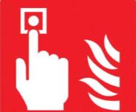  Fire/Evacuation |  |  |  |  |   First Aid |  |  |  |  |  |  |  |  |   Pollution/Spill |  |  |  |  |  |  |  | Other
Fire extinguishers available on all vehicles |  |  |  |  | FA Equipment available on all vehicles |  |  |  |  |  |  |  |  | Spill kits available on all vehicles
Personal protective equipment (PPE) requirements
 |  |  |  |  |  |  |  |  |  |  |  |  |  |  |  |  |  |  |  |  |  |  |  |  |  |  | Other |  |  |  |  | Other
Head |  | Foot  (BSEN180 2034:2004 |  | Hi-Vis Vest  (Class 3) |  |  |  |  | Hand |  |  |  | Eye |  |  |  |  | Hearing |  |  | Fall Arrest
✓ |  | ✓ |  | ✓ |  |  |  |  | ✓ |  |  |  | ✓ |  |  |  |  | ✓ |  |  | ✓
Construction Dust (note: construction dust is harmful and can lead to fatal lung diseases such as silicosis)
Will the work create dust or fumes |  |  |  |  |  |  |  |  |  |  |  |  |  |  |  |  |  |  |  |  |  |  |  |  | ✓ |  |  | Yes |  |  |  |  | No
Identify specific control measures to avoid or minimise dust or fumes |  |  |  |  |  |  |  |  |  |  |  |  |  | Any cutting equipment must be fitted with a self-contained dust suppression device.
Identify respiratory protective equipment (RPE) that will be required if dust or fumes cannot be avoided |  |  |  |  |  |  |  |  |  |  |  |  |  | Minimum standard FFP3 RPE to be used when required.
Hazardous Materials
Are hazardous materials to be used? |  |  |  |  |  |  |  |  |  |  | Yes | ✓ |  |  |  | No | Are COSHH/DSEAR data sheets available? |  |  |  |  |  |  |  |  | ✓ |  |  | Yes |  |  |  |  | No
Attach or identify specific controls required from COSHH/DSEAR risk assessment |  |  |  |  |  |  |  |  |  | COSHH SDS available on requested.
Permit Required (tick below)
✓ | Permit to work (general) |  |  |  |  |  |  |  |  | Permit to enter (confined spaces) |  |  |  |  |  |  |  |  |  |  |  |  |  | Permit to dig
 | Hot-work permit |  |  |  |  |  |  |  |  | Out of hours work permit |  |  |  |  |  |  |  |  |  |  |  |  |  | Other
Details of person issuing permit |  |  |  |  |  |  | Permit to work to be issued by NWR (if applicable)
Description of safe method of work
SCOPE

The scope of work covered by this method statement explains the correct procedure for entering underground structures which involves the following activities:

PROGRAMME

• Erection of all appropriate SLG
• Erection of appropriate guarding
• Opening of underground structure
• Carry out gas test
• Dewater where necessary
• Classify underground structure
• Replace structure cover and remove all, plant & equipment leaving site clean and tidy

ASSOCIATED DOCUMENTS

• Traffic management plan where applicable
• Generic risk assessments
• COSHH assessments
• The appropriate craft manual
• All applicable ISIS documentation
• All applicable training documentation
• Site induction register
• Site diary
• Safe to dig permit
• Confined space entry permit where applicable
• SLG Code of practice

RESPONSIBILITIES

Line managers / supervisors shall:

• Ensure that all operatives have the appropriate competency to conduct their work safely
• Ensure that the necessary work equipment and PPE are made available.
• Be the initial point of contact in the event of an accident / incident.
• Ensure that all relevant checks are completed and the results recorded.
• Ensure that all operatives have access to the current issue of the appropriate Manuals & instructions.
• Ensure that all the required equipment issued is in a safe condition.
• Ensue that calibration and maintenance records are up-to-date for relevant equipment
• Ensure that all Operatives are carrying out their responsibilities listed below.
• Ensure that any damage to BT or any public/private infrastructure is recorded and reported immediately to the appropriate contact

All Operatives shall:

• Carry out a point of work risk assessment and ensure that all control measures are implemented in accordance with the generic risk assessment and record any additional risks and required control measures on the point of work risk assessment.
• Ensure that the site diary is completed
• Ensure that all relevant permits have been completed
• Ensure that all tools & equipment are in a safe condition before use
• Ensure that all ladders and steps are in a safe condition before use
• Ensure that the work site complies with the requirements of the relevant method statement and instructions.
• Ensure the work site is safe prior to commencement of works (for both USL personnel, contractors and members of the public)
• Ensure that the correct PPE is worn.
• Ensure visitors to site are made aware of the hazards associated with the activity being carried out before being granted entry and they are wearing the correct PPE for the site and sign the visitors’ log.
• Ensure any damage identified on site is reported to the line manager immediately.
• Report any damage to BT or any public/private infrastructure.

TRAINING AND COMPETENCY

• BT Personnel safety
• Use of Manhole lifter no 4
• Induction
• Manual handing and kinetic lifting
• Appropriate NRSWA units
• Confined space (top person) where applicable
• Confined space rescue & recovery where applicable
• Bt Underground safety

PLANT/MATERIAL/EQUIPMENT

• Water test kit
• De-watering pump
• 4 head gas detection unit
• Rescue & recovery winch (where appropriate)
• Breathing equipment (where appropriate)
• Sufficient SLG to facilitate guarding in accordance with NRSWA
• Appropriate box key’s, block & roller and manhole lifter
• 110v generator
• 110v air blower

PERMITS

• HA opening notice
• Pumping / discharge permit as and when required basis if ground water disposal is required
• Permit to enter confined space where applicable

CONTROLS FROM RISK ASSESSMENT

All control measures are contained in the generic and point of work risk assessments provided

PPE requirements
• Hard hat
• Safety boots (not shoes or rigger boots)
• Eye shields
• Gloves
• Ear defenders where applicable
• Dust masks where applicable
• Safety harness where applicable
• Overalls
• Hi-Viz jerkin / jacket
• Hi-Viz trousers where applicable

EMERGENCY PROCEDURES

Site-specific emergency arrangements

• In the event of any accident/incident the supervisor must be informed at the earliest opportunity.
• All incidents must be reported via Telsafe
• The supervisor will be the main point of contact during any accident/incident.
• The H&S team will be kept Informed of all accident/incidents
• A first aid kit will be available on the worksite.

WORK DELIVERY

• The contents of this method statement and the associated risk assessment’s will be approved by Bt Openreach

• The contents of this method statement and the associated risk assessment’s will be briefed by the site representative to all work personnel before work starts on site.

• A point of work risk assessment will be conducted before work commences and be included in the site H&S file, where appropriate

• All site personnel shall be adequately trained and competent in the use of site-specific plant and equipment required for the associated activities.

• Work will commence by setting up the site management as required for the proposed work areas, in accordance with chapter 8 standards and any relevant traffic management plans.

• The proposed work area will be guarded to protect site operatives and third parties from proposed excavation and construction activities.

• Prior to entry, the operative must determine the underground structures classification using the following criteria:

Classification of BT Underground structures
Joint boxes to be treated as none a confined space, gas testing to be carried out and results recorded.

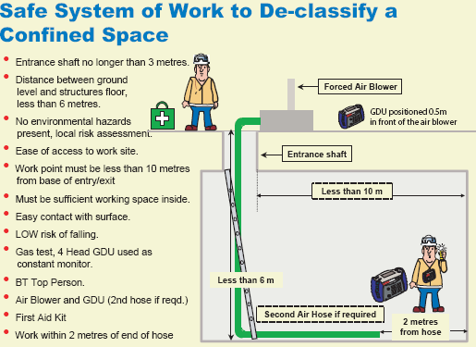

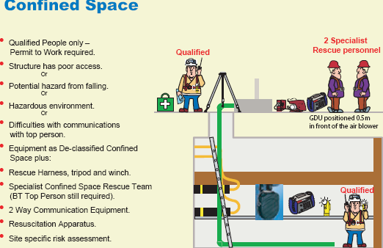

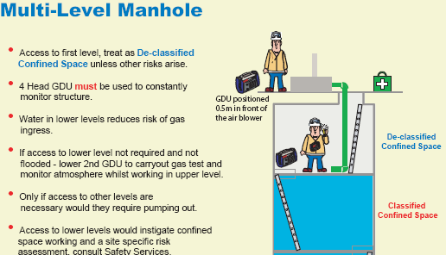

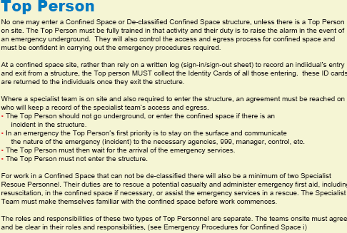

Once the appropriate classification has been determined the following process must be completed:

• The structure cover should be raised using the appropriate box key’s, block & roller or manhole lifter sufficiently to facilitate the Lowering a 4-head gas detection unit into the underground structure to check for poisonous gases and oxygen depletion / enrichment. The GDU shall remain in place with no alarms.

• If a positive test is detected the structure should be closed and a supervisor contacted immediately.

• A manhole lifter must be used when lifting carriageway covers, if it is not possible to use a manhole lifter the supervisor must be contacted and a site-specific risk assessment must be carried out and documented describing the reason a manhole lifter cannot be used and detailing the Safe manual handling system deployed.

• If the underground structure is identified as a de-classified manhole and on completion of a satisfactory gas test a fresh air blower shall be used to ventilate the underground structure

• If the Underground structure is identified as de-classified manhole personnel may only enter the underground structure if a BT safety top man trained person is present on site.

• If the underground chamber is flooded, the foreman will need to determine whether it can be pumped out with a local pump or whether a gulley sucker is required.

• The foreman or lead operative on site may only sanction the pumping of 5m2 of clean water from any underground structure.

• Before pumping, the water must be tested for cleanliness, this is done by drawing a sample of water using a clean jar and comparing it with a data sheet (see below). The result of any test shall be annotated on the relevant site point of work risk assessment.

Water must not be locally pumped out if it is not clean.

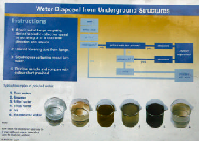

All plant, equipment and materials will be removed from site.

INSPECTION AND TEST

All statutory inspection’s, test and maintenance records will be maintained in accordance with the appropriate regulations and Ct procedures.

APPENDIX 1 – APPLICABLE RISK ASSESSMENTS
The generic task based and point of work risk assessments will be available as part of the operatives craft manual and on site documentation

APPENDIX 2 – APPLICABLE COSHH ASSESSMENTS
All the relevant COSHH assessments will be available on site as part of the operative’s craft manual and on site documentation
Type |  |  |  |  |  |  |  |  |  |  |  |  |  |  | Details of inspections/test certificates
DEWALT 24v Handheld drill |  |  |  |  |  |  |  |  |  |  |  |  |  |  | N/A
PALFINGER PKG7001 Crane |  |  |  |  |  |  |  |  |  |  |  |  |  |  | LOLER CERT ATTACHED
HILUX CHERRY PICKER |  |  |  |  |  |  |  |  |  |  |  |  |  |  | LOLER CERT ATTCAHED
GENERAL HAND TOOLS/SLINGS |  |  |  |  |  |  |  |  |  |  |  |  |  |  | LOLER CERTS ATATCHED
Briefing register
A copy of this briefing register must be attached to the method statement, together with other relevant information (such as the associated risk assessments, permits or COSHH assessments).
Supervisor in charge of the work
I confirm that I have read and understand the requirements of this method statement and associated risk assessments and have communicated them to operatives under my control and to those who may be affected by its requirements.

Note: it is important that you test the operatives’ understanding and assume they have read and understood the method statement and risk assessments.
Name |  |  | C.Alexander |  |  | Position |  |  |  | Director |  |  |  |  | Signature |  |  |  | C.Alexander |  |  |  |  | Date |  |  | 14.11.2023
Operatives/workforce carrying out the work
I understand and will agree to adhere to the contents of this method statement and the associated risk assessments. I have attended a site induction/briefing that explained the general site rules and necessary site specific arrangements.
Name |  |  |  |  |  | Position |  |  |  |  |  |  |  |  | Signature |  |  |  |  |  |  |  | Date
If you have any doubt about information given or contained in this method statement – ask for clarification.

